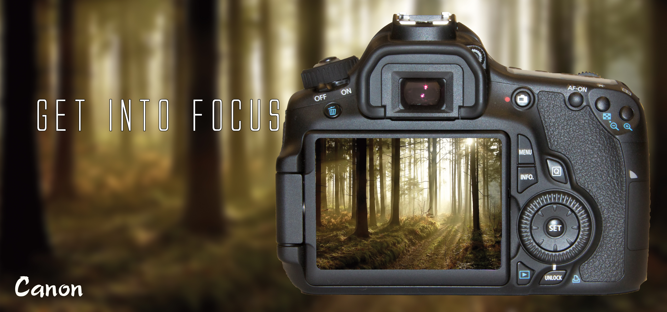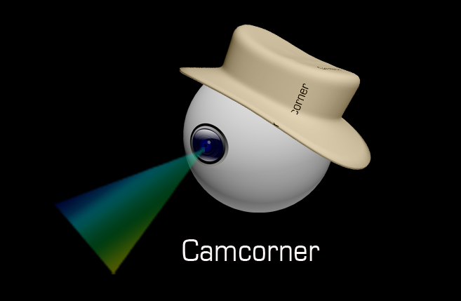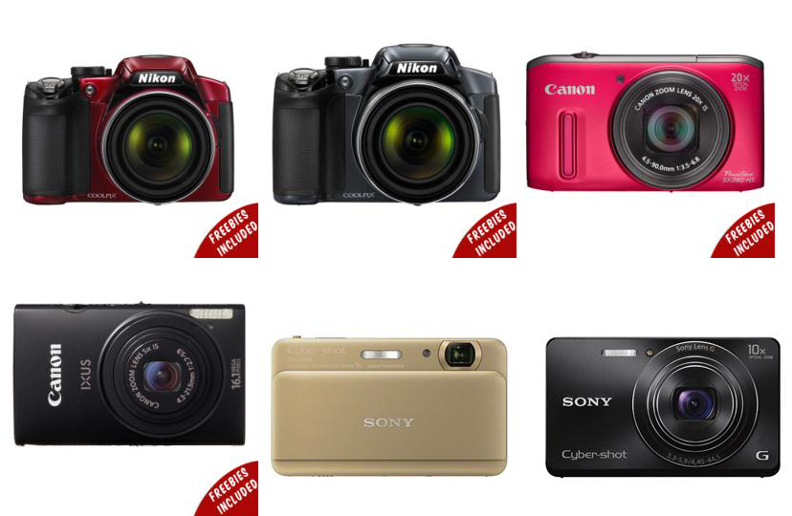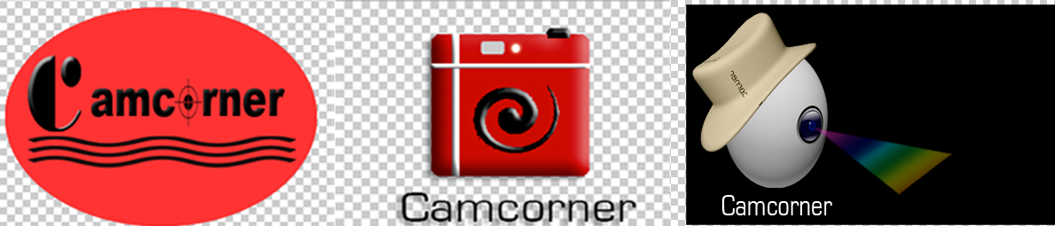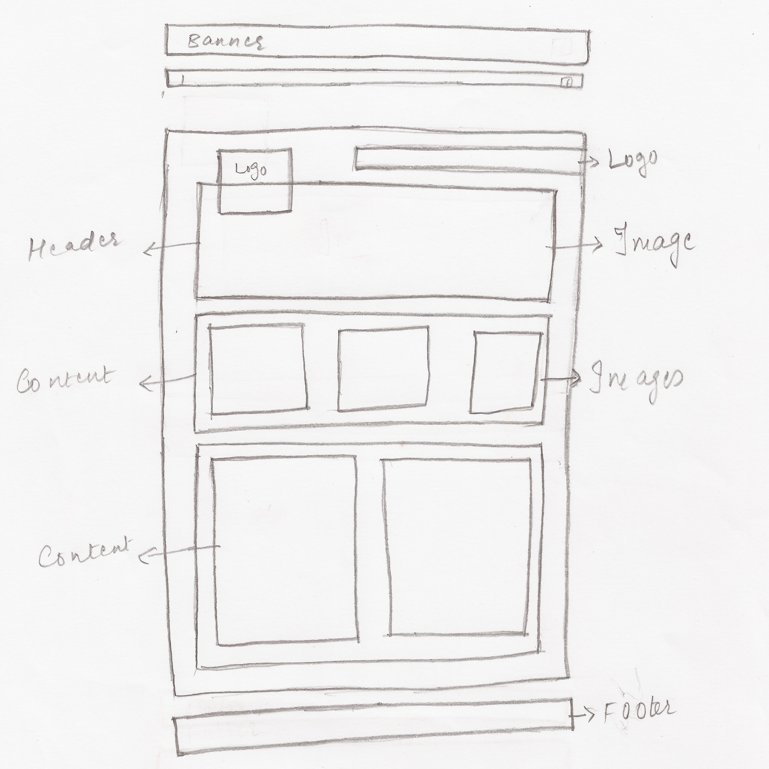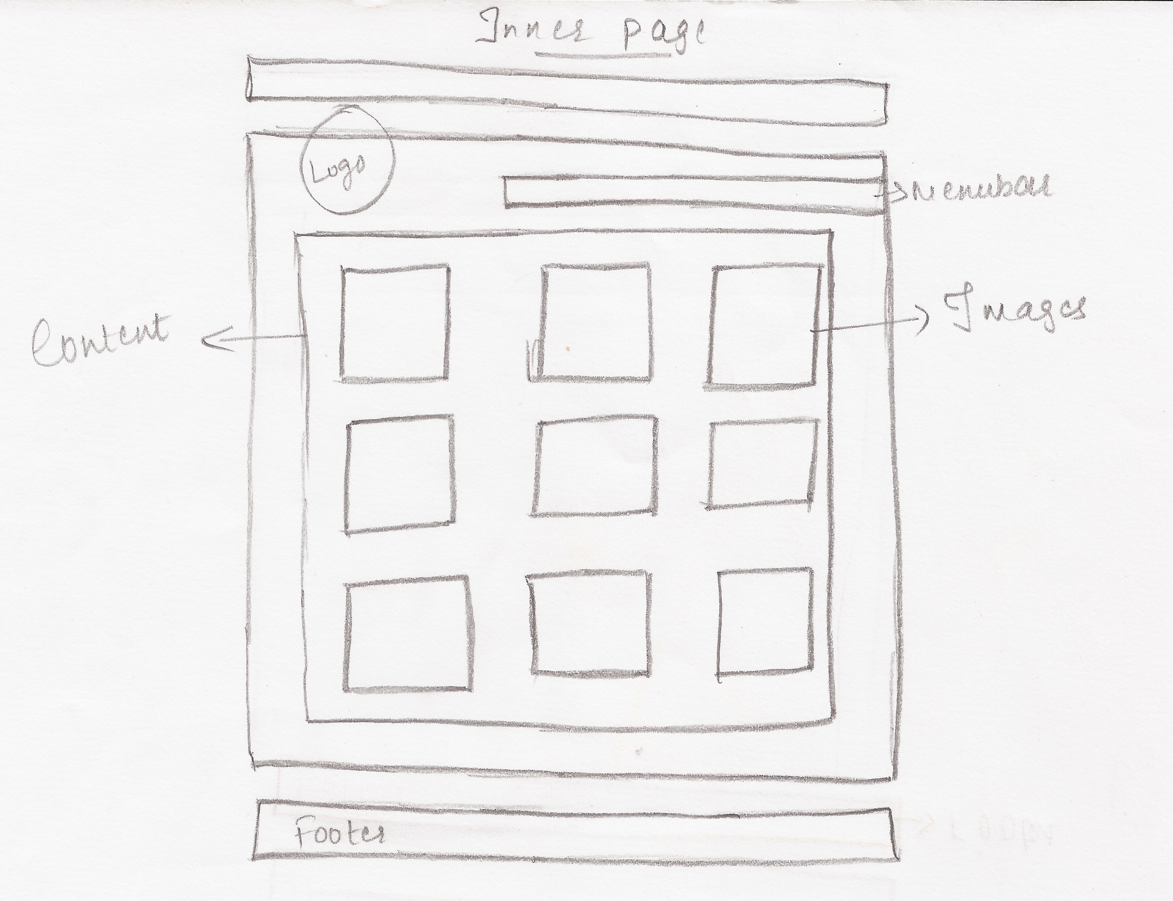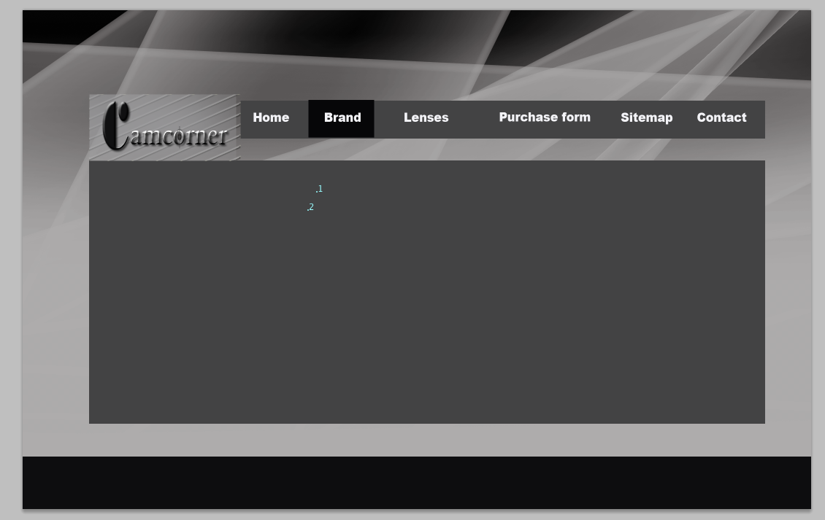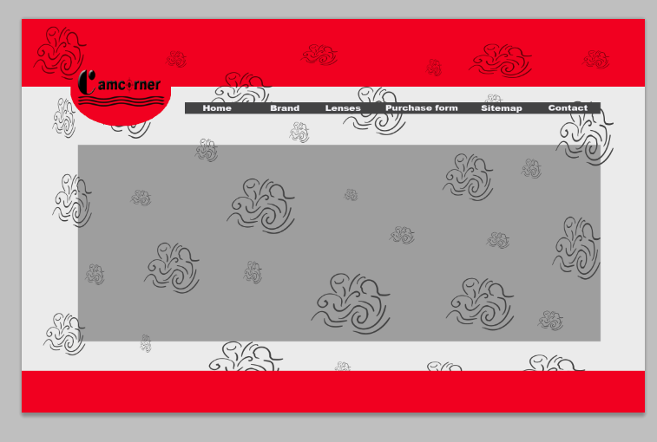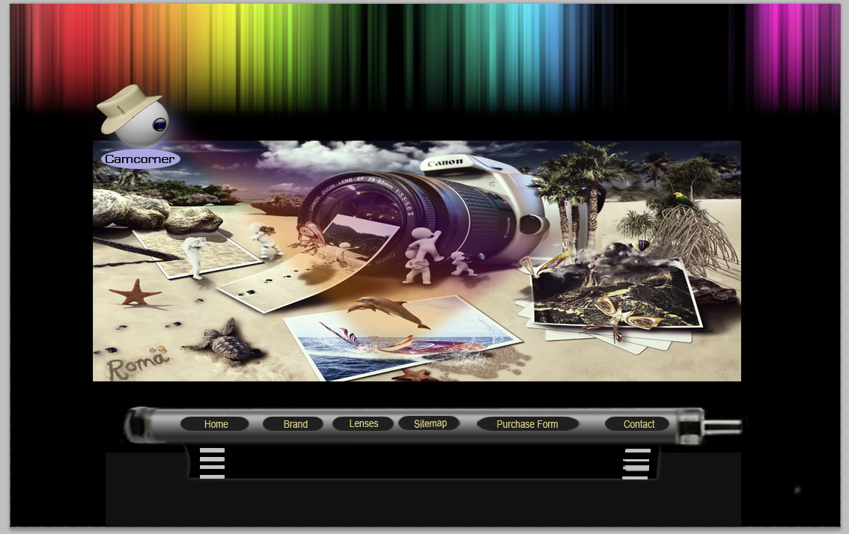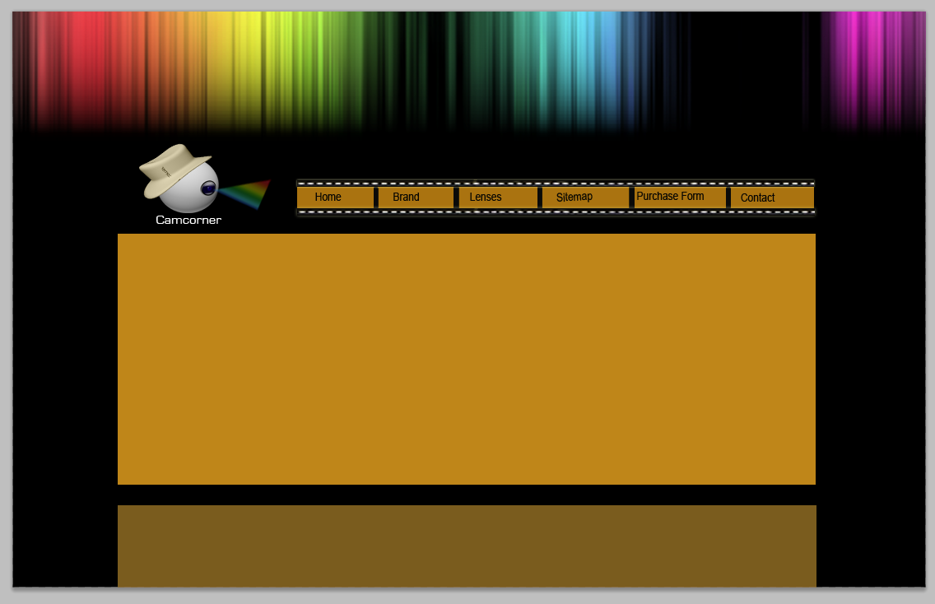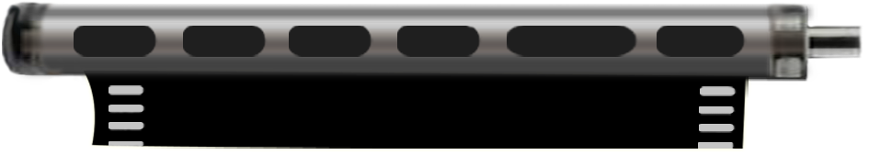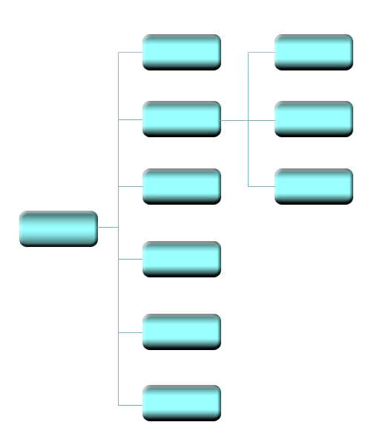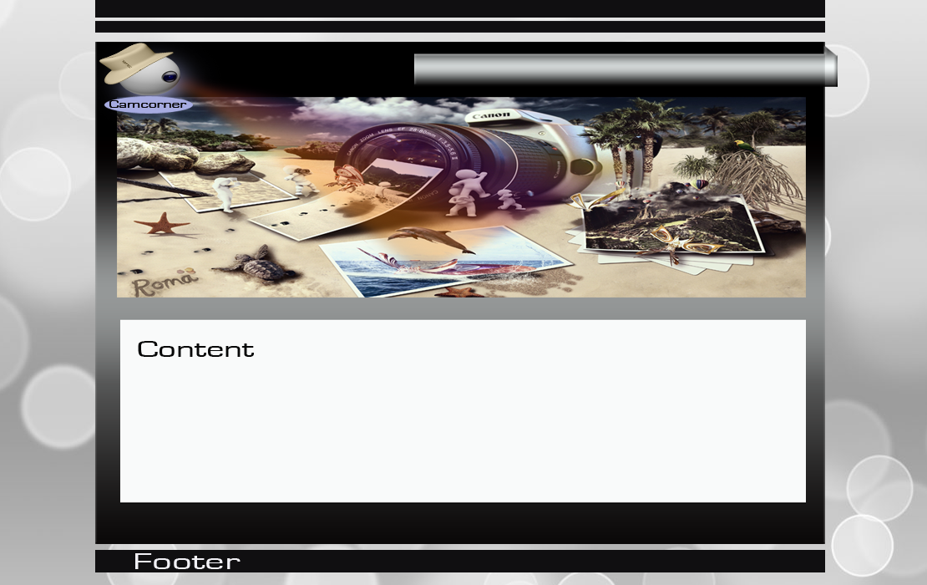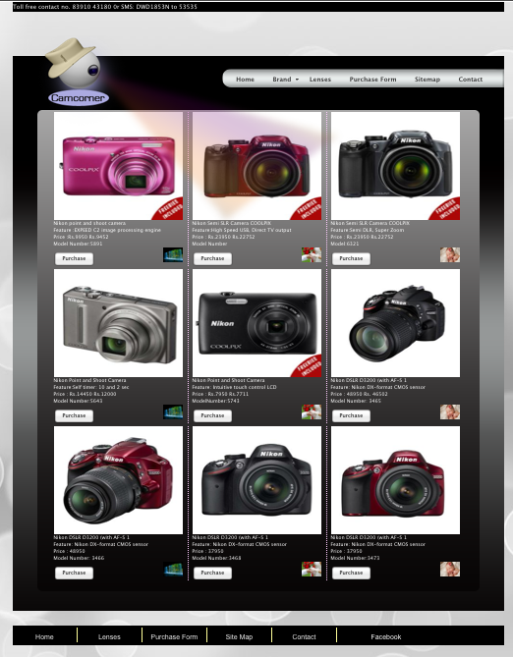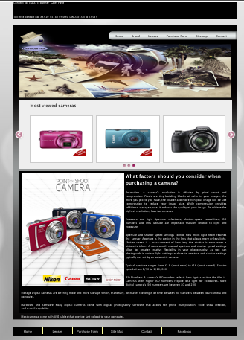

**Web designer and developer: Khushi Nagwani**

**Enrollment no.: 585049**

**Roles: Graphic design, Logo design, Web page design, Flash animation, Web page implementation and documentation.**

2013

**Documentation for e-project 2012-2013**

**Web Project:**

**“Camera-On-Net”**

Name of Faculty Guide

Prof. Manan Panchal

Arena Animation, Wanowrie, Pune

Organization  
Arena Animation

Wanowarie, Pune Maharastra

[www.arena](http://www.arena) multimedia.com

**Table Of Content**

Page 2

**Project details**

Problem Statement……………………………………………………………………………………………………. 04

Specifications ………………………………………………………………………………………………………….. 04

Tools……………………………………………………………………………………………………………………. 04

**Pre-production………………………………………………………………………………………………………………... 05**

Background texture, color combination and font…………………………………………………………………… 06

Images used in home page banner…………………………………………………………………………………. 07

Intro Animation……………………………………………………........................................................................ 08

Working on designing logo………………………………………........................................................................ 09

Working on designing layout…………………………………………………………………………………………. 10

Working on designing layout…………………………………………………………………………………………. 11

Working on designing web page…………………………………………………………………………………….. 12

Working on designing web page…………………………………………………………………………………….. 13

Working on designing menu bar……………………………………………………………………………………... 14

Working on designing menu bar……………………………………………………………………………………... 15

Working on designing sitemap image……………………………………………………………………………….. 16



**Table Of Content**

Page 3

**Production……………………………………………………………………………………………………………………..** 17

Logo…………………………………………………………………………………………………………………….. 18

Background texture and color……………………………………………………………………………………….. 19

Menu bar image and site map image……………………………………………................................................ 20

Web layout…………………………………………………………………………………………………………….. 21

Screen shot……………………………………………………………………………………………………………. 22

Into Animation…………………………………………………………………………………………………………. 23

Website Authoring……………………………………………………………....................................................... 24

Images downloaded web address………………………………………………………………………………….. 25

Images downloaded web address………………………………………………………………………………….. 26

**Post Production………………………………………………………………………………………………………………** 27

**Post Production………………………………………………………………………………………………………………** 28



**Problem Statement**

**Specifications**

Page 4

**Intro Animation:**

An introduction page with a flash animation.

**Home Page:**

Home page gives the over view of the website

With animated banner on the top of the page.

**Brand:**

Consist of three navigation which gives link to three different brands.

**Lenses:**

Should consist of 12 various lenses with a brief description.

**Purchase Form:**

The form has to be designed to capture the complete details of the user and the transaction details.

**Sitemap:**

Diagram in a visual form and all the links of the diagram should be programmed for hyperlink.

**Contact:**

Provide the developers name role and email along witha dummy address.

To create an informative and commercial site for the photographers who love to know the details of cameras available in the market. The site should cover the camera details from all the brands available in the market.

### Links to the web site

Intro animation

Home page

Brand

Lenses

Purchase form

Sitemap

Contact

* Adobe Photoshop CS5
* Adobe Flash CS5
* Adobe Dreamweaver CS5

**Tools Used In The Project:**

After going through the problem statement and understanding the requirement of the camera web site, following are few of the ideas that came into my mind.

* The most important thing that represents the product or the product web site is logo. I designed different logos as to match the requirement of the camera web site.
* After logo I selected the web site name as camcorner as I though it has to be one of the best website selling cameras on net. Cam represents camera and corner as one of the website selling cameras.
* Second thing which I though important is web site backgrounds. I made few of the background and down loaded few of them from the internet and tested the same on the web site. As this web site was for camera the design had to be simple to understand the message. Putting too many colors can make the web site look very glossy. So I selected gray and black background and gave gradient effect on the containers.
* After working on logo and website background I started working on the web site layout i.e., Home page and the inner pages.
* As per company’s requirement three brands has been used for the camcorner web site i.e, Nikon, Canon and Sony.
* 

**Table Of Content**

Page 5

**Background Texture, Color Combination And Font**

Page 6

**Background texture**: Grey color bubble effect

**Color Combination**: Grey and black for the website background and gradient effect for the layout.

**Font**: Color black or white has been given through the pages of web site.

Below mentioned font effects are given in the body section:

Font color: #FFF (White)

Font size: 12px

Font-family: “Lucida Grande", Tahoma, Arial, Verdana, sans-serif

**Images Used In Home Page Banner**

Page 7

As per requirement I have downloaded few of the below given images for the banner section at the top of the home page.

The first page of the web site is an into animation page with a soft piano music. Animation has been done using Flash CS5.

I have inserted the image that shows the clarity of the photos clicked from the camera. And have used the real pictures (instead of the camera images) downloaded from the website to show how useful the camera can be at every step of your life to capture the happy moments, nature picture, wildlife and much more so as to preserve it as a memories life long. To show if the photo clicked from the best cameras always gives best output.

At the end of the animation I have inserted the logo of the web site, which represents the web site and offers best online deals.

**Intro Animation**

**e Banner**

Page 8

**Working On Designing Logo**

**e Banner**

Page 9

Finally I settled with the third logo as I thought it would better suit my website

Logos should be effective to represent the web site, keeping this in mind I experimented few of the below given pictures

**Working On Designing Layout**

**e Banner**

Layout is a part of graphic design that deals in the arrangement and style treatments of elements (content) on a page. This page gives descriptions for page layout.

Page 10

**Working On Designing Layout**

**e Banner**

Page 11

**Working On Designing Web Page**

**e Banner**

Page 12

**Working On Designing Web Page**

**e Banner**

**Working On Designing Web Page**

**e Banner**

Page 13

I short listed the above given page design but then dropped the idea of using them because the colors used in the top of the pages were not looking good on web site as it is in the image above.

The pages have been designed in Photoshop CS5.

Page 14

**Working On Designing Menu Bar**

**e Banner**

Initially I was suppose to use the above given image as a menu bar background but somehow it did not match with the website design.

Image 1

Next I started designing the menu bar as I wanted to give the texture/look of camera roll. Below given are the images that I made in the Photoshop CS5

Image 1

**Working On Designing Menu Bar**

**e Banner**

Page 15

Image 2

Image 3

I finally selected image no. 3 as my menu bar background as I thought it would give decent look to the web site and also that I have given camera roll texture to the image.

**Working On Designing Site Map**

**e Banner**

I have designed the below given sitemap image in Photoshop CS5.

Page 16

**Production**

**e Banner**

Page 17

A production function relates to the action of making or manufacturing from components or raw materials, or the process of being so manufactured.

**Production**

**e Banner**

Page 18

A **logo** carries the image of the company. **Logo** design of a company is an iconic symbol of company products or services.

Of all the logos that I have experimented, below given logo suits the requirement of the company.

Following is the png image of the logo.

Folo

**Background Texture And Color**

**e Banner**

I have downloaded the web page background from internet and made Layout and container background in Photoshop CS5 using gradient tool.

Page 19

Below given are the web page and layout background.

**Menu Bar Image And Site Map Image**

**e Banner**



Have used the image in sitemap page and psd file for same is in the raw file CD.

The final image for menu bar background that I have used is given below:

Page 20

**Web Layout**

**e Banner**

Page 21

All the graphics of web page was designed using Photoshop CS5. Photoshop is considered one of the leaders in photo editing software. The software allows users to manipulate, crop, resize and correct the color.

Below given is the final out put of the web layout.

**Screen Shot Of Home Page And Inner Page**

**e Banner**

Page 22

**Intro Animation**

**e Banner**

Page 23

At the end of the intro animation I have inserted the logo to represent the company.

Flash intro is the first page that the user will land on. I have used few of the below mentioned images for the intro animation slide show. Music at the background of the slide show mesmerizes the user.

**Web Authoring**

**e Banner**

Page 24

Web site is made using Adobe Dreamweaver CS5. It uses HTML along with CSS, JavaScript, Spry assets and flash.

CSS has been used for easy separating the design from the actual content. CSS belonging to the web site is present in css folder in websites root.

JavaScript carousel is been used in the header section of the home page. Scripts are stored in js folder.

Spry assets have been used for menu bar and it is stored in spry assets folder.

All the images used in the website is stored in image folder.

Following are few of the links from which I have downloaded the images:

**Web Authoring**

**e Banner**

Page 25

The images used in intro animation have been downloaded from below mentioned links:

* [www.Portraits.vanburenphotography.com](http://www.Portraits.vanburenphotography.com)
* [www.thedayigavebirth.com](http://www.thedayigavebirth.com)
* [www.hdwalls.it](http://www.hdwalls.it)
* [www.m.redd.com](http://www.m.redd.com)

The camera logos used in the web site have been downloaded from below given links:

* [www.cloudtimes.org](http://www.cloudtimes.org) - Sony logo
* [www.crwrepair.net](http://www.crwrepair.net) -Canon logo
* [www.myona.com](http://www.myona.com) -Nikon logo

Website background image have been downloaded from:

* [www.barkaparka.com](http://www.barkaparka.com)

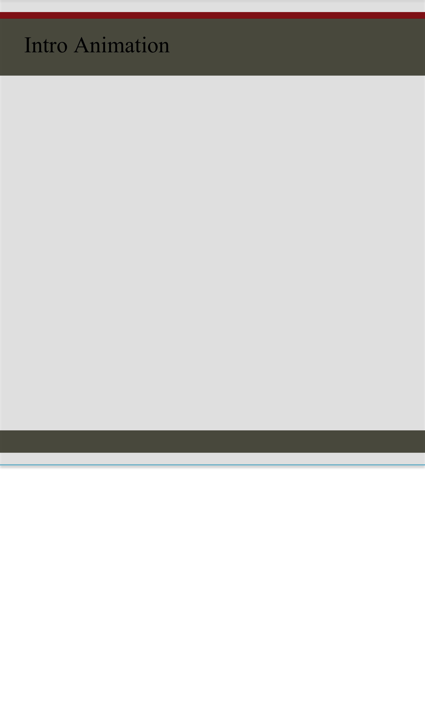

**Images Downloaded Web Address**

**e Banner**

Page 26

The images of the camera used have been downloaded from below mentioned link:

* [www.yebhi.com](http://www.yebhi.com)

The site map image used in the sitemap page have been downloaded from below given link:

* [www.infinitetechnopark.com](http://www.infinitetechnopark.com)

The image used in the contact us form page have been downloaded from:

* [www.nimtweb.org](http://www.nimtweb.org)



**Post Production**

**e Banner**

Page 27

Testing

Website is tested in Chrome, Firefox, and Internet Explorer to make sure it is displayed as intended on the three most widely used browsers.

Mastering

Burning on CD

1. First CD:

Heading of CD-“HTML files”

Project name :Camera on net

Centre name :Arena-Wanawadi, Pune

Developer’s name : Khushi Nagwani

Enrollment no. : 585049

Content of CD: A folder named “Camera-On-Net” will contain all the files required just to deploy the website

**Post Production**

**e Banner**

Page 28

2. Second CD:

Heading of CD : “Raw files and documentation

Project name : Camera-On-Net

Centre name : Arena-Wanawadi, Pune

Developer’s name : Khushi Nagwani

Enrollment no. : 585049

Content of CD: Following folders will be included in the CD

* Camera-On_Net_Raw_Files
* Camera_On_Net_Documentation

**Web designer and developer:** Khushi Nagwani

**Enrollment no.:** 585049

**Roles:** Graphic design, Logo design, Web page design, Flash animation, Web page implementation and documentation.

2013

**Knowledge enhancement and experience**

Working on this project was a good experience for me. I got to learn more about tools and technique in designing, implementing and developing the website. From getting the project, designing graphics, making the layout, implementing the same to build a website, getting the outputs and finally documenting it.

The tips given in the statement were helpful.

**Acknowledgement**

Thank you very much for offering me this project as I got to learn working on real time web development. Would like to thanks Mr. Manan in helping me with tips and tricks to accomplish the project.